## VISVESVARAYA TECHNOLOGICAL UNIVERSITY

“JNANA SANGAMA”, BELGAUM-590018



**A Mini Project Report on**

# “Food Order Management System”

**A Mini Project report submitted to the V Semester degree of Bachelor of Engineering in Computer Science of Visvesvaraya Technological University, Belgaum**

**Submitted by**

#### SINCHANA P [4UB20CS043] UMME ZAIBA [4UB20CS053]

**Under the Guidance of**

#### Smt. Kanyakumari K T

Lecturer,

Computer Science & Engineering, UBDTCE



##### DEPARTMENT OF COMPUTER SCIENCE & ENGINEERING

**University B. D. T. Engineering College, Davanagere-577004**

**2022-2023**

**UNIVERSITY B. D.T. ENGINEERING COLLEGE, DAVANAGERE-577004**

**DEPARTMENT OF COMPUTER SCIENCE & ENGINEERING**



**CERTIFICATE**

Certified that the mini project work entitled ***“*Food Order Management System”** has been successfully carried out by **UMME ZAIBA (4UB20CS053)** student of **Computer Science & Engineering Department, University B. D. T. College** of **Engineering** in partial fulfillment for the award of Bachelor of Engineering in **Computer Science & Engineering Department** in **Visvesvaraya Technological University**, Belgaum during academic year 2020-2021. It is certified that all corrections/suggestions indicated for Internal Assessment have been incorporated in the report deposited in the department library. The mini project report has been approved as it satisfies the academic requirements in respect of mini project work prescribed for the degree.



|  |  |  |
| --- | --- | --- |
| **Signature of Guide**  **Smt. Kanyakumari K T** |  | **Signature of HOD**  **Dr. Shreedhara K S** |
| **Dept. of CS&E, UBDTCE** | **External Exam** | **Chairman & HOD Dept. of CS&E UBDTCE** |
| Name of the Examiner |  | Signature and Date |
| 1) |  | 1) |
| 2) |  | 2) |

### DECLARATION

I am Student of V Semester BE, in Computer Science & Engineering**, University**

**B. D. T. Engineering College, Davangere** hereby declare that the mini project entitled **“Food Order Management System”** has been carried out under the guidance of **Smt. Kanyakumari K T** and submitted in partial fulfillment of the requirements for the V Semester Bachelor’s degree in **Computer Science & Engineering** of Visvesvaraya Technological University*, Belgaum* during academic year 2022- 2023.

**UMME ZAIBA [4UB20CS053]**

## CONTENTS

|  |  |  |
| --- | --- | --- |
| **Sl.**  **No** | **INDEX** | **Page. No** |
| **1.** | **ABSTRACT** |  |
| **2.** | **ACKNOWLEDGEMENT** |  |
| **3.** | **CHAPTER 1: INTRODUCTION** |  |
| **4.** | **CHAPTER 2: HARDWARE AND SOFTWARE REQUIREMENTS** |  |
| **5.** | **CHAPTER 3: SYSTEM DESIGN AND ANALYSIS** |  |
| **6.** | **CHAPTER 4: IMPLEMENTATION** |  |
| **7.** | **CHAPTER 5: TESTING** |  |
| **8.** | **CHAPTER 6: SNAPSHOTS** |  |
| **9.** | **CONCLUSION** |  |
| **10.** | **FUTURE ENHANCEMENT** |  |
| **11.** | **REFERENCES** |  |

### ABSTRACT

In the world of digitalization, we have always strived to achieve efficiency in terms of time and space. The Food Order Management System enhances the speed and standardization of taking the order by just a click, saving both the efforts and time of the customers. This way of management system makes it more convenient for managers to manage orders, collect, analyze data and provide better service. The demand of combining the convenience of digital business with traditional delivery service is increasingly growing.

The food order system sets up the menu online and the customers easily places the order. Customer can choose and explore one or more items to place an order. At the end, customer gets order confirmation message. The user’s orders are maintained in the admin panel. Customers can add ratings and can write review about the various experiences of the food and the services.

Online food ordering system, greatly simplifies the ordering process for both the customer and the restaurant. Once the order is placed it is entered in the database and retrieved in pretty much real time. This allows restaurant employees to quickly go through the orders as they are received and process all orders efficiently and effectively with minimal delays and confusion. The admin can update about the food which is featured and active. It also allows them to keep track of whether the order is delivered, being delivered or cancelled.

This project contains entity relationship model diagram and introduction to relation model. There is also design of the database of food order management system based on relation model.

### ACKNOWLEDGEMENT

The satisfaction and euphoria that accompany the successful completion of any task would be incomplete without the mention of the people who made it possible, whose constant guidance and encouragement crowned the efforts with success.

We would like to profoundly thank **University B. D. T. Engineering College, Davangere** for providing such a healthy environment for the successful completion of project work.

It gives us immense pleasure to thank **Dr. Shreedhara K S** Professor and Head of Department for his constant support and encouragement.

Also, we would like to express my deepest sense of gratitude to my guides **Smt. Kanyakumari K T** Lecturer, Department of Computer Science & Engineering for their constant support and guidance throughout the work.

We would also like to thank the Department of Computer Science & Engineering and all other teaching and non-teaching staff of Computer Science Department who has directly or indirectly helped me in the completion of the project work.

Last, but not the least, we would hereby acknowledge and thank my parents and friends who have been a source of inspiration and also instrumental in the successful completion of the project work.

**INTRODUCTION**

The main purpose of maintaining database for Food Order Management Systems is to reduce the manual errors involved in the booking and cancelling of orders and make it convenient for the customers and providers to maintain the data about their customers and about the food available at them. Due to automation many loopholes that exist in the manual maintenance of the records can be removed.

The speed of obtaining and processing the data will be fast, allowing the end user to interact with the system through a rich interface provide a much more enjoyable user experience, particularly for the non-technical users which will account for the majority of the system’s users.

In addition, this isolation layer also protects the integrity of the database by preventing users from taking any action outside those which the system is designed to handle. Because of this design pattern, it is essential to enumerate exactly which functions a user will be presented and these functions are outlined below, grouped by component.

The Food Order Management System facilitates the passengers to explore about the foods available on the basis of featured and active criteria, ordering of the food and cancelling it, enquiring about the status of the ordered food, etc.

The aim of case study is to design and develop a database maintaining the records of different orders, food status, and customers. The record of customer includes their number, name, email, phone, address and status based on which the customer order is delivered, being delivered or cancelled.

**REQUIREMENTS**

* 1. **HARDWARE REQUIREMENTS**

Processor : Intel Core Duo 2.0 GHz or more

RAM : 1 GB or More

Hard disk : 80GB or more

Monitor : 15” CRT or LCD monitor

Keyboard : Normal or Multimedia

Mouse : Compatible mouse

#### SOFTWARE REQUIREMENTS

Front End : Visual Basic 2005 Express edition with SQL

Server compact edition Microsoft SDK (2.0 or 3.0) Back End : My SQL server, PHP, HTML, CSS Operating System : Windows 32 or 64 bits

Server : Google Chrome

### SYSTEM DESIGN AND ANALYSIS

# Schema Diagram

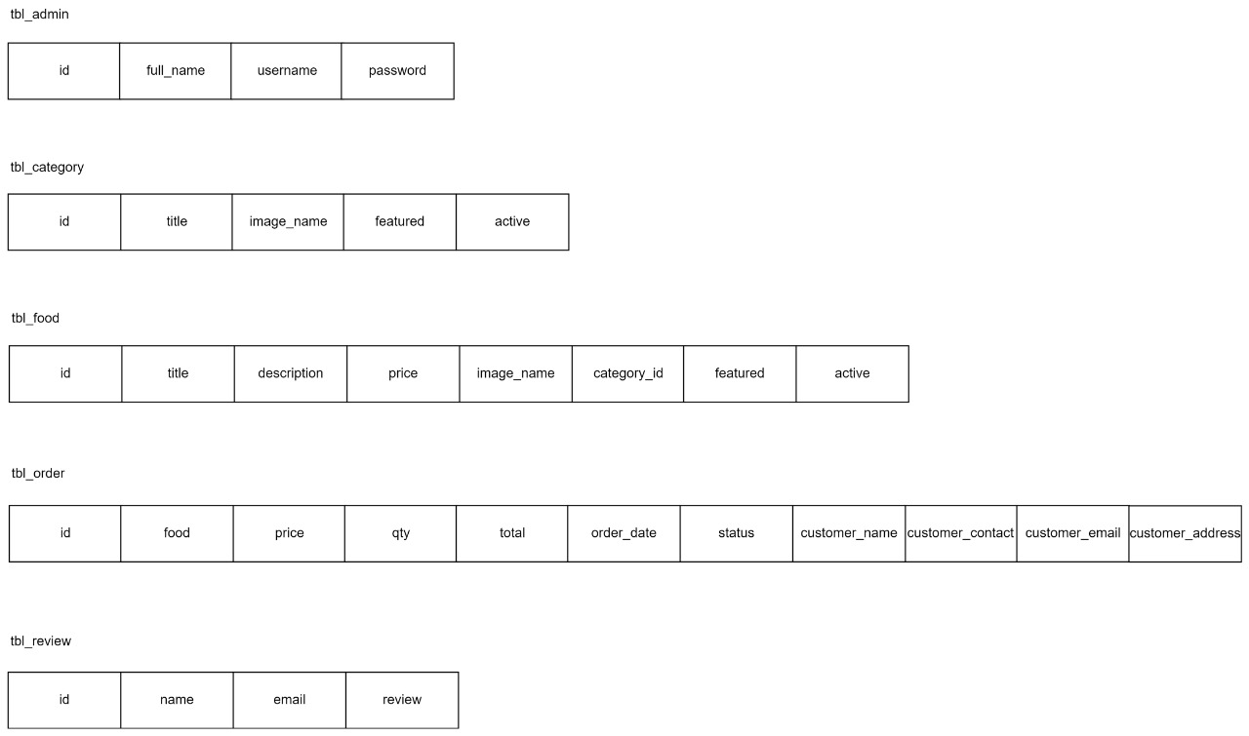

## ER Diagram

The entity-relationship data model is based on a perception of a real world that consists of a collection of basic objects called entities and of relationships among these objects. An entity is an “object” in the real world that is distinguishable from other objects.

For e.g., each customer is an entity and foods can be considered to be entities. Entities are described by a set of attributes.

For e.g., the attributes username and password describes a particular credential for customer or admin. The set of all entities of the same type and the set of all relationships of the same type are termed as an entity set and relationship set respectively.

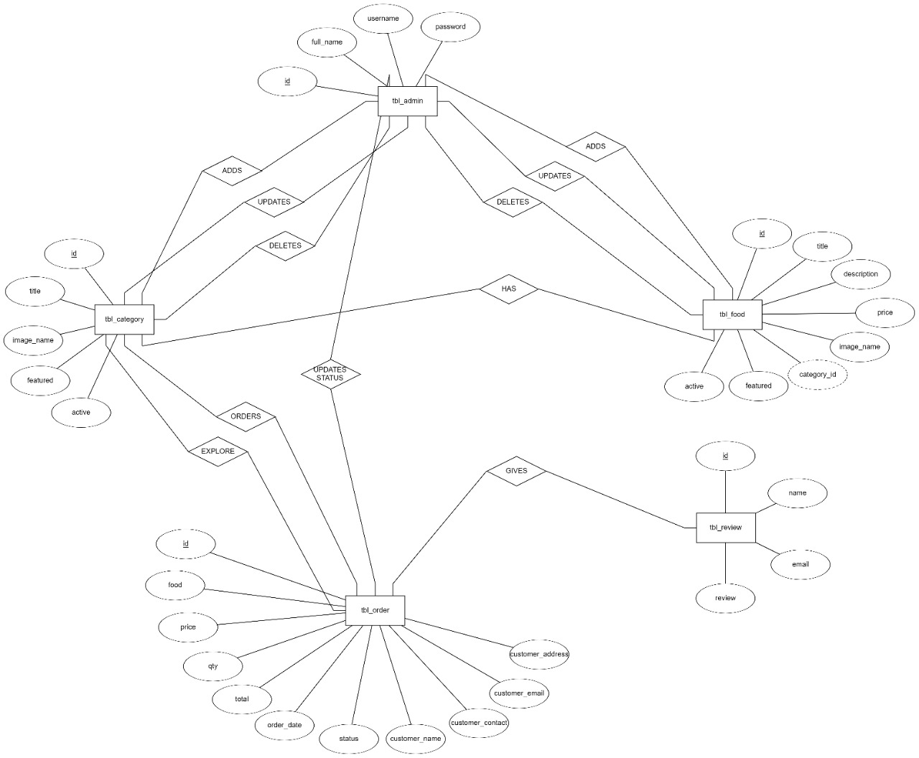

**IMPLEMENTATION**

**Users of the web Ordering system:**

These users must be provided with the following functionality:

• Create an account.

• Manage their account.

• Log in to the system.

• Navigate the restaurant’s menu.

• Select an item from the menu.

• Customize options for a selected item.

• Add an item to their current order.

• Review their current order.

• Remove an item/remove all items from their current order.

• Place an order.

• Receive confirmation in the form of an order number

By not including extraneous functions, I am moving towards my goal of simplifying the ordering process.

**Admin Management System:**

The menu management system will be available only to restaurant employees/admin. The functions afforded by the menu management system provide user with the ability to, using a graphical interface:

* Add a new/update/delete vendor to/from the menu.
* Add a new/update/delete food category to/from the menu.
* Add a new/update/delete food item to/from the menu.
* Add a new/update/delete option for a given food item.
* Update price for a given food item.
* Update default options for a given food item.
* Update additional information (description, photo, etc.) for a given food item.

Of the three components, the order retrieval system is functionally the simplest. Like the menu management system, it is designed to be used only by restaurant employees, and provides the following functions:

• Retrieve new orders from the database.

• Display the orders in an easily readable, graphical way.

• Mark an order as having been processed and remove it from the list of active orders.

It is anticipated that the functionality provided by this component will be one of the first things noted by the restaurant user, as they will have to go through it to configure their menu, etc. before beginning to actually take orders.

## TESTING

**Test case**: Admin and customer login into the system

|  |  |  |
| --- | --- | --- |
| Input | Expected result | Actual result |
| Click on the order button without entering name and address. | Appropriate message must be displayed to the customer. | User friendly error message is displayed to customer and admin. |
| Typing irrelevant food keywords in the search bar menu. | Appropriate message must be displayed to the customer. | It gives the user friendly message by displaying erroneous |
| Click on add Admin button without entering the username and password. | Appropriate message must be displayed to the admin. | User friendly message is displayed to admin. |
| Click on the change password button without knowing the current password. | Appropriate message must be displayed to the admin. | User friendly message is displayed to the admin. |

## TABLES

###### Table structure for table `tbl_admin`

CREATE TABLE `tbl_admin` (

  `id` int(10) UNSIGNED NOT NULL,

  `full_name` varchar(100) NOT NULL,

  `username` varchar(100) NOT NULL,

  `password` varchar(255) NOT NULL

) ENGINE=InnoDB DEFAULT CHARSET=utf8 COLLATE=utf8_general_ci;

###### Table structure for table `tbl_category`

CREATE TABLE `tbl_category` (

  `id` int(10) UNSIGNED NOT NULL,

  `title` varchar(100) NOT NULL,

  `image_name` varchar(255) NOT NULL,

  `featured` varchar(10) NOT NULL,

  `active` varchar(10) NOT NULL

) ENGINE=InnoDB DEFAULT CHARSET=utf8 COLLATE=utf8_general_ci;

###### Table structure for table `tbl_food`

CREATE TABLE `tbl_food` (

  `id` int(10) UNSIGNED NOT NULL,

  `title` varchar(150) NOT NULL,

  `description` text NOT NULL,

  `price` decimal(10,2) NOT NULL,

  `image_name` varchar(255) NOT NULL,

  `category_id` int(11) NOT NULL,

  `featured` varchar(10) NOT NULL,

  `active` varchar(10) NOT NULL

) ENGINE=InnoDB DEFAULT CHARSET=utf8 COLLATE=utf8_general_ci;

###### Table structure for table `tbl_order`

CREATE TABLE `tbl_order` (

  `id` int(10) UNSIGNED NOT NULL,

  `food` varchar(150) NOT NULL,

  `price` decimal(10,2) NOT NULL,

  `qty` int(11) NOT NULL,

  `total` decimal(10,2) NOT NULL,

  `order_date` datetime NOT NULL,

  `status` varchar(50) NOT NULL,

  `customer_name` varchar(150) NOT NULL,

  `customer_contact` varchar(20) NOT NULL,

  `customer_email` varchar(150) NOT NULL,

  `customer_address` varchar(255) NOT NULL

) ENGINE=InnoDB DEFAULT CHARSET=utf8 COLLATE=utf8_general_ci;

###### Table structure for table `tbl_review`

CREATE TABLE `tbl_review` (

  `id` int(10) UNSIGNED NOT NULL,

  `name` varchar(250) NOT NULL,

  `email` varchar(200) NOT NULL,

  `review` varchar(255) NOT NULL

) ENGINE=InnoDB DEFAULT CHARSET=utf8 COLLATE=utf8_general_ci;

## SNAPSHOTS

##### Home Page:

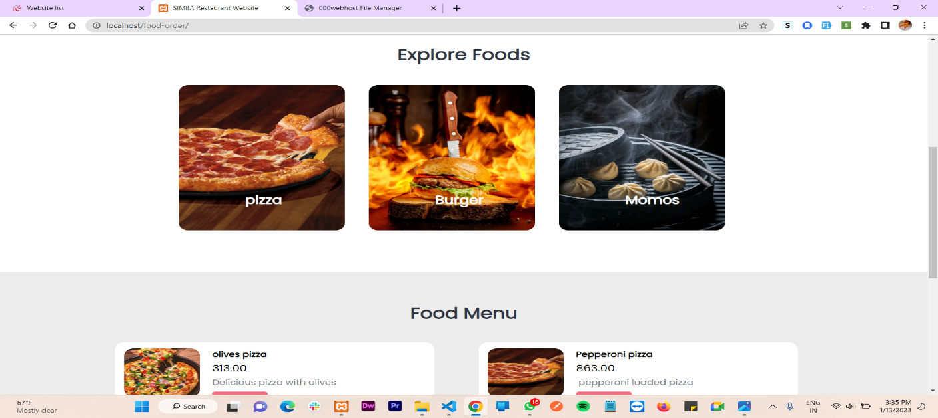

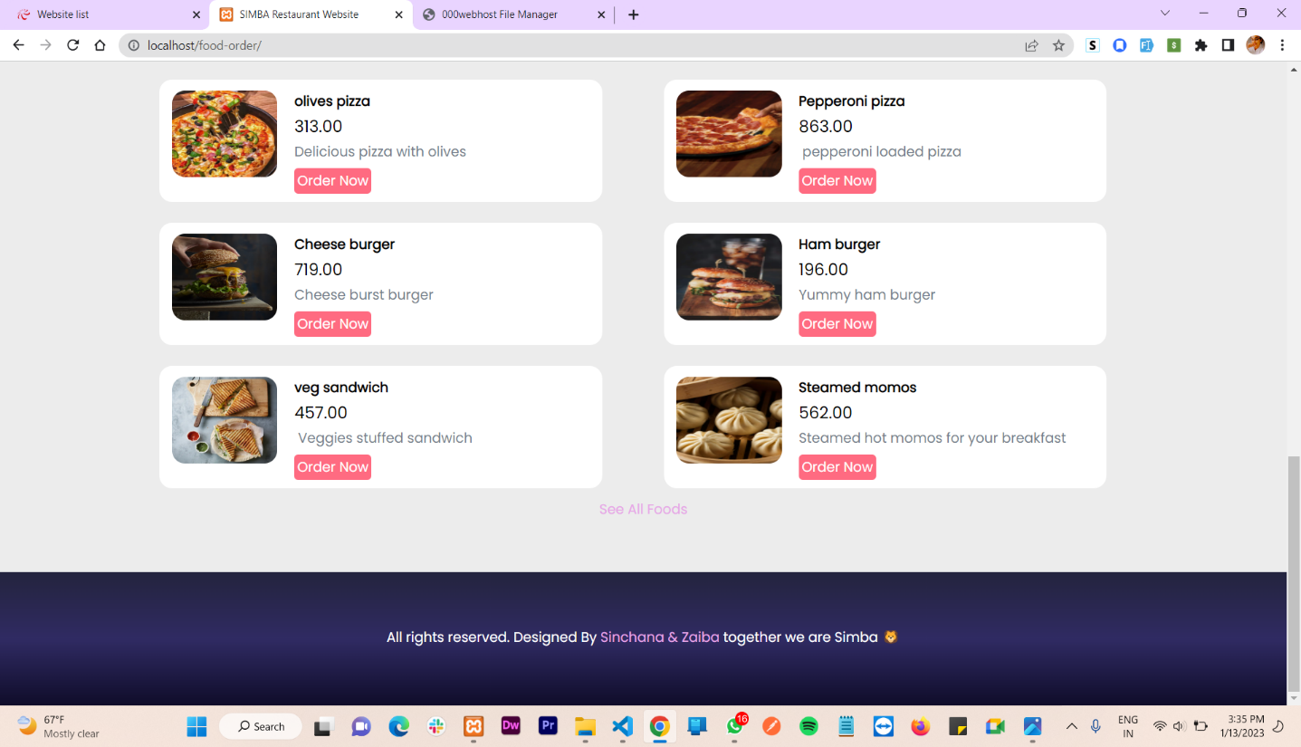

###### Category Page:

###### 

###### Foods Page:

###### 

**Food Order Page:**

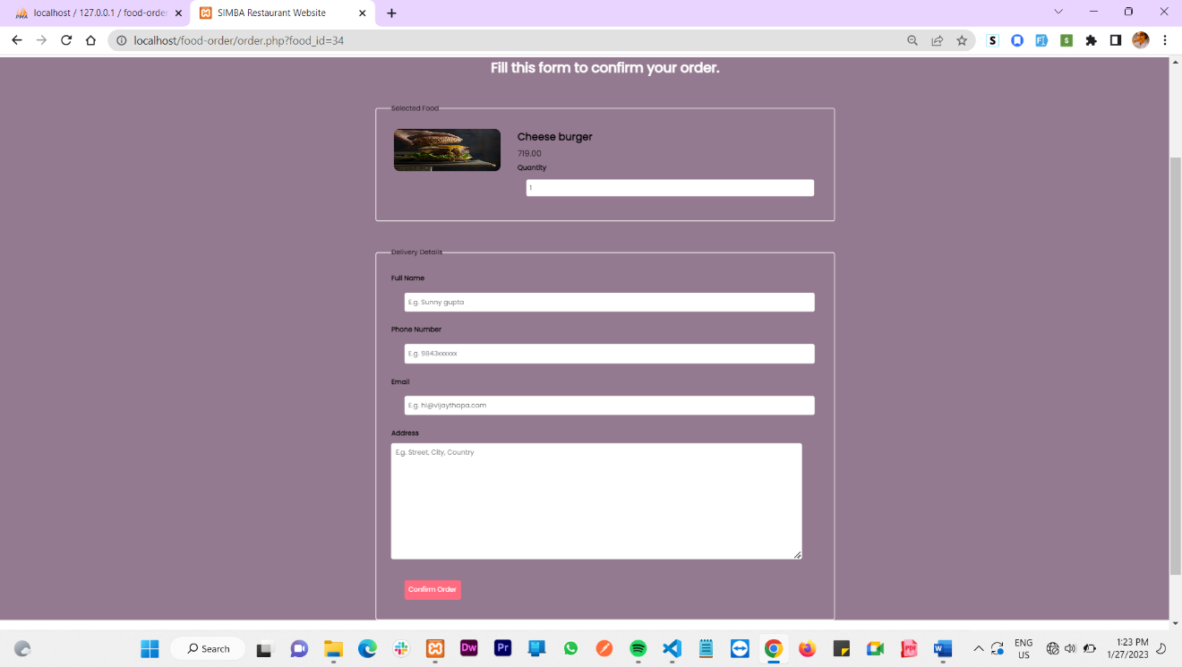

**Customer Reviews Page:**

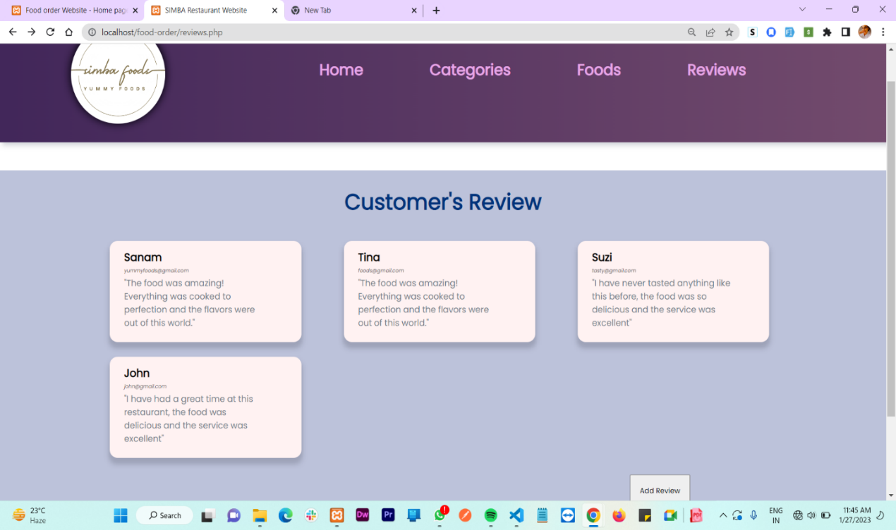

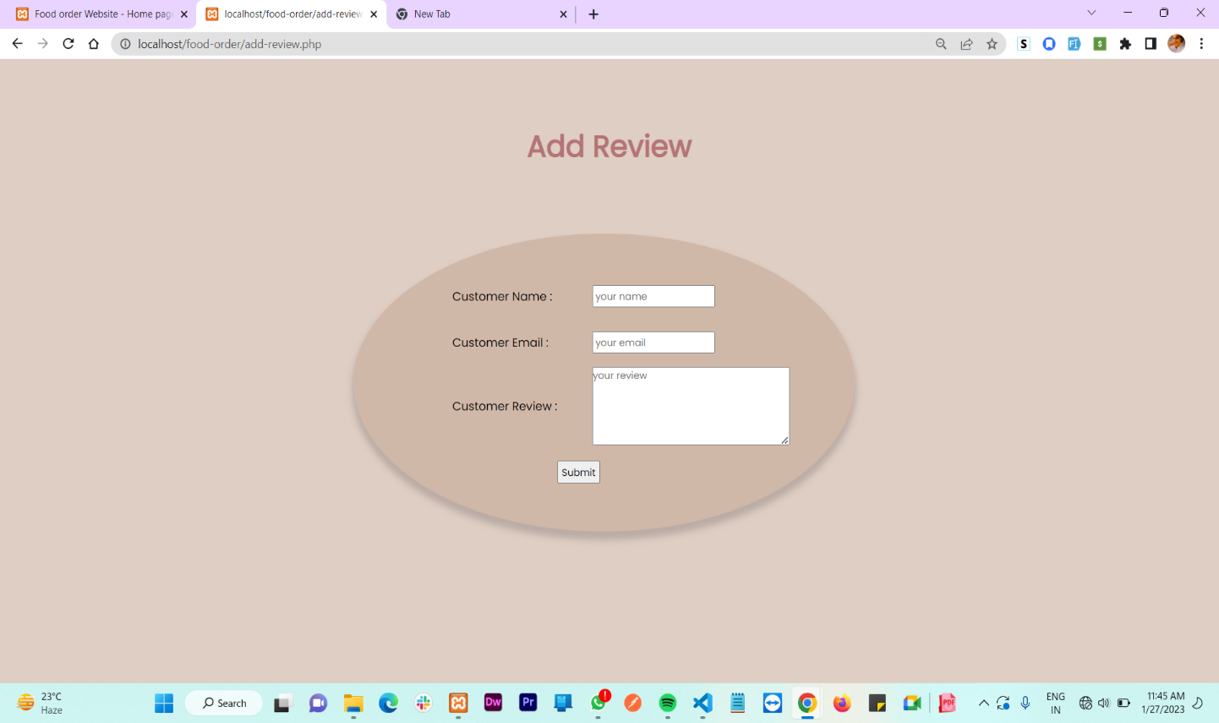**Add Review Page:**

**Admin Panel Snapshots**

**Admin Login Page**:

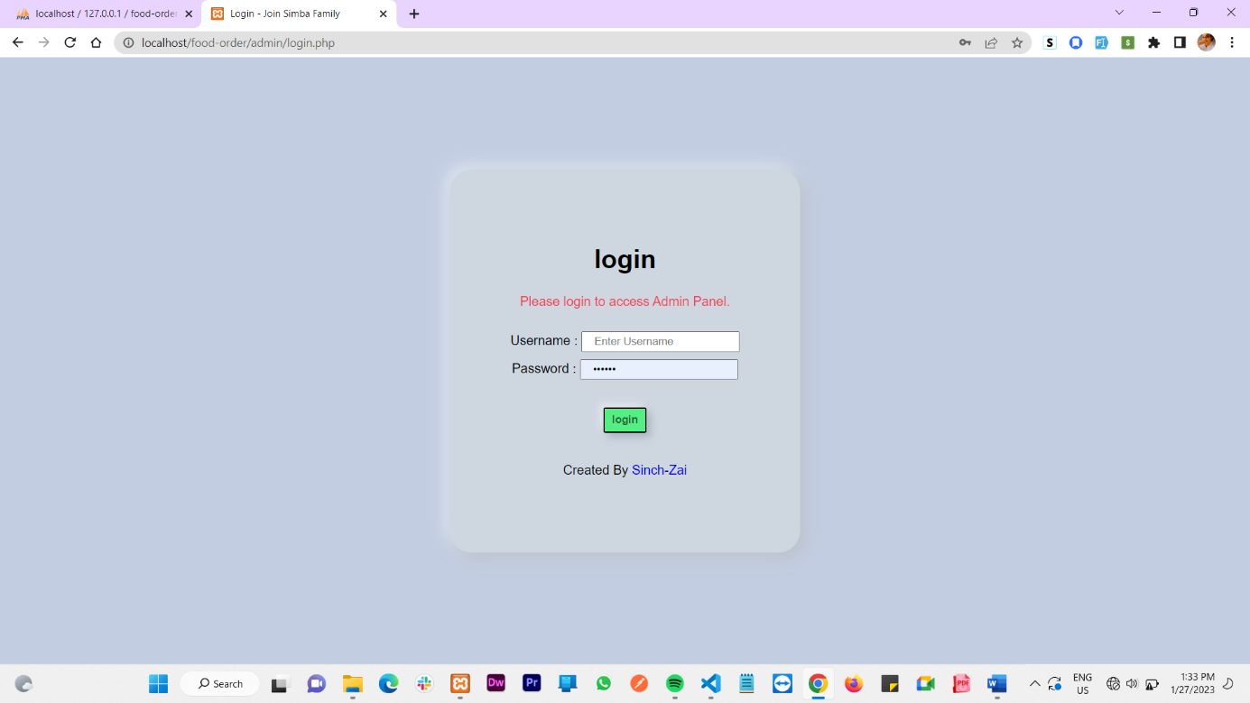

**Admin Dashboard**:

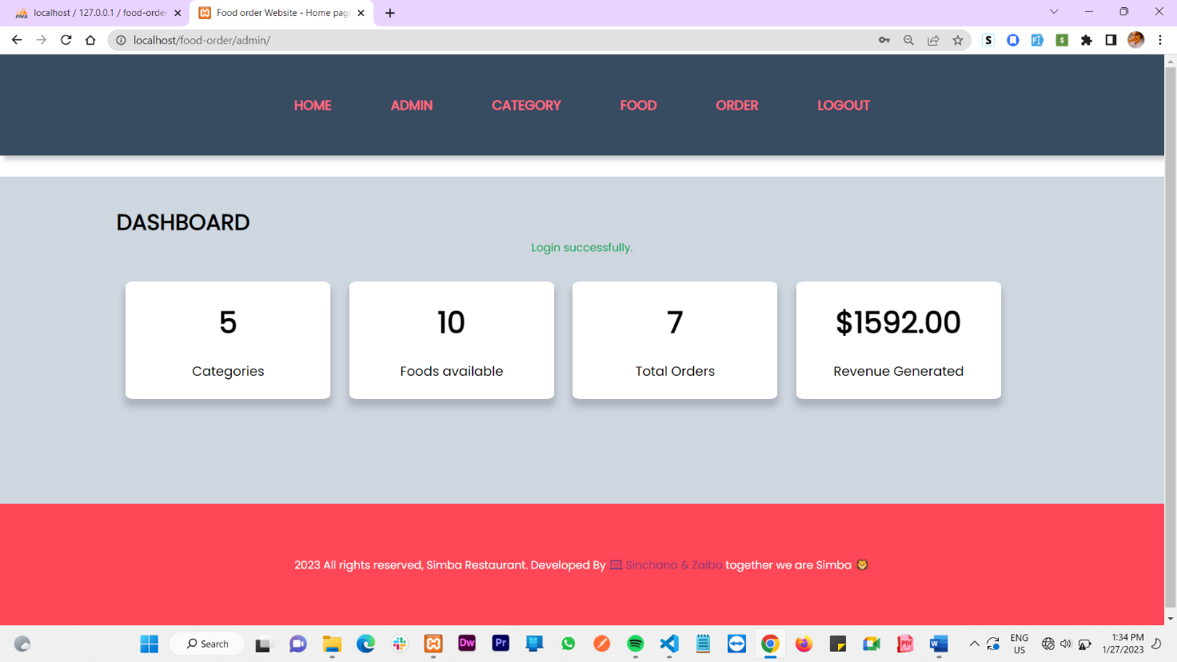

**Manage Admin:**

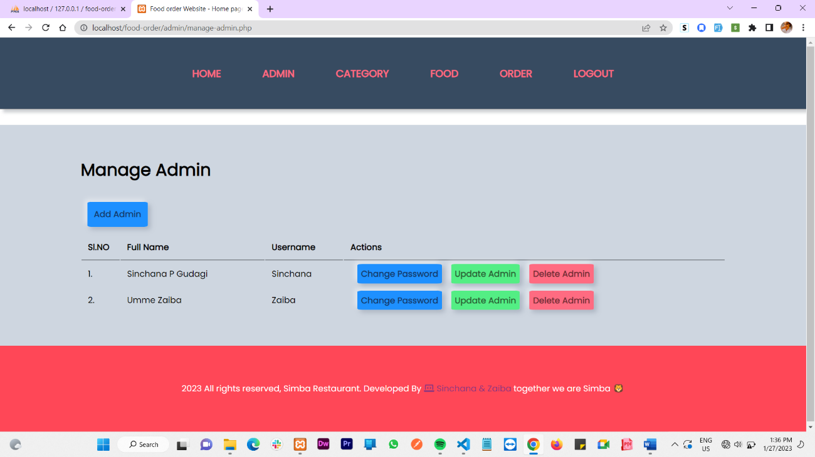

**Add Admin:**

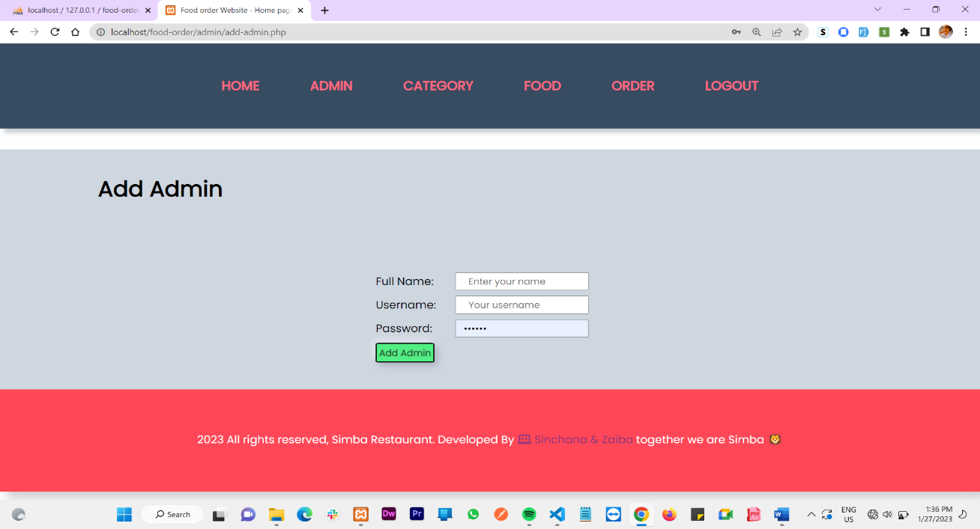

**Update Admin:**

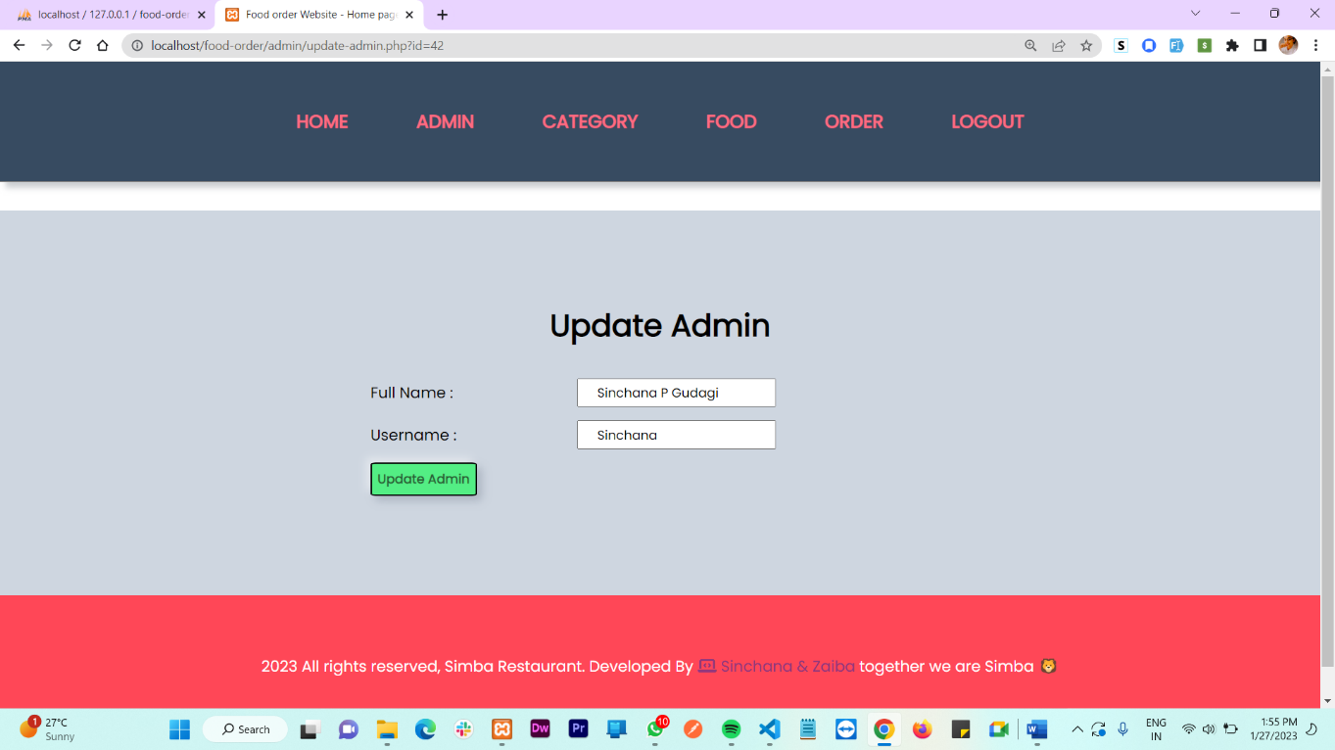

## Update Password:

## 

## Manage Category:

## 

## 

## Add Category:

## 

## Update Category:

## 

## Manage Food:

## 

## Add Food:

## 

## Update Food:

## 

## Manage Order:

## 

## Update Order:

## 

## CONCLUSION

The food order management system is more efficient, fast, reliable, user friendly. Over and above the proposed system does not have any possibility of data loss during processing. The food system will serve as a useful and secure approach for ordering the food among various categories or selected food items and quantity. It provides easy way for the admin to manage various food items ordered by the customers and updating appropriate status to see the current activity.

## FUTURE ENHANCEMENT

**The following section describes the work that will be implemented with future releases of the software.**

* Customize orders: Allow customers to customize food orders Online Food Ordering System Page 114
* Enhance User Interface by adding more user interactive features. Provide Deals and promotional
* Offer details to home page. Provide Recipes of the Week/Day to Home Page ✓ Payment Options: Add different payment options such as PayPal, Cash, Gift Cards etc. Allow to save payment details for future use.
* Allow to process an order as a Guest
* Delivery Options: Add delivery option
* Order Process Estimate: Provide customer a visual graphical order status bar
* Order Status: Show only Active orders to Restaurant Employees.
* Order Ready notification: Send an Order Ready notification to the customer
* Restaurant Locator: Allow to find and choose a nearby restaurant
* Integrate with In store touch screen devices like iPad
* Making a mobile app for the user is also a first step development.

## BIBILOGRAPHY

1. Fundamentals of Database System, Ramez Elmasri and Shamkant B. Navathe, 7th Edition, 2017, Pearson Textbook.
2. [www.php.net](http://www.php.net)
3. [www.codeacademy.com](http://www.codeacademy.com)
4. [www.w3schools.com](http://www.w3schools.com)
5. Udemy.com